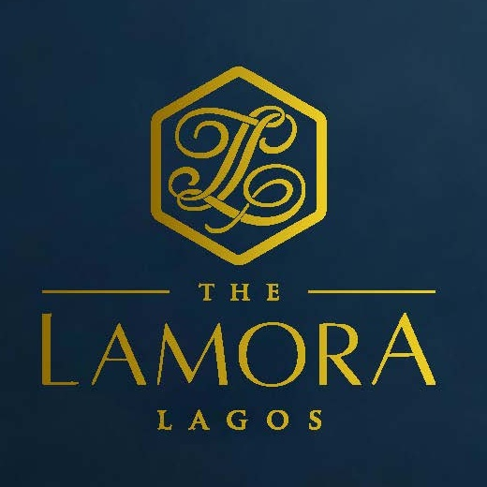
PROPERTY FACT SHEET
The Lamora Lagos
Premium luxury serviced apartment hospitality in Victoria Island

31 serviced suites • Restaurant • VIP Lounge • Coffee Shop
Meeting Room / Boardroom • Work-from-Home Space • Gym • Pool • Laundry

PRIVATE. REFINED. PERSONAL.

PROPERTY FACT SHEET

01 / AT A GLANCE

A private residence with hotel discipline
The Lamora Lagos is a low-density luxury apartment hotel designed for guests who value privacy, residential space, professional reliability and personalised service.
Location  Victoria Island, Lagos, Nigeria | Inventory  31 serviced apartment suites

Positioning  Premium luxury lifestyle apartment hotel | Maximum Occupancy  Up to 116 guests across the accommodation inventory

Soft Opening  1 November 2026 | Official Opening  1 December 2026

Stay Profiles  Nightly, weekly, monthly and bespoke extended-stay agreements | Core Segments  Corporate, diplomatic, expatriate, project, family, VIP and premium leisure

The Lamora promise
More privacy than a large hotel, more service than an independent apartment, and more utility than a conventional residence.

ACCOMMODATION

02 / APARTMENT COLLECTION

31 suites. Five ways to stay.
The accommodation mix supports solo executives, couples, families, long-stay residents, project teams and VIP entourages.
Apartment Category | Units | Max PAX | Positioning Role
Studio Suite | 6 | 2 | Efficient premium base for individual executives and short stays.
1 Bedroom Suite | 6 | 2 | Separate bedroom and living space for business and extended stay.
2 Bedroom Suite | 12 | 4 | Core family, colleague-sharing and project-team product.
3 Bedroom Suite | 6 | 6 | Premium multi-guest solution for families and senior teams.
4 Bedroom Presidential Suite | 1 | 8 | Flagship private residence for executive, family and VIP hosting.

Residential Comfort  Living space and residential functionality designed for short and extended stays. | Hotel-Grade Servicing  Professional housekeeping, guest service, security and operational standards.

Multi-Bedroom Flexibility  Two-, three- and four-bedroom formats support families, executive teams and shared assignments. | Extended-Stay Ready  Weekly, monthly, project and corporate-residence pricing can be structured around length of stay and account volume.

OUTLETS & FACILITIES

03 / ONE ADDRESS ACROSS THE DAY

Stay, work, meet, dine and unwind without leaving the property.
Restaurant  Contemporary Afro-Fusion dining with breakfast, lunch, dinner, room service and corporate-hosting relevance. | VIP Lounge  A discreet, controlled-access environment for premium beverages, executive hosting and private social occasions.

Coffee Shop  Specialty coffee, premium and herbal teas, pastries, light meals, grab-and-go and productive daytime use. | Meeting Room / Boardroom  Private executive scale for leadership meetings, interviews, presentations, workshops and strategy sessions.

Work-from-Home Space  Professional workspace with connectivity, power, ergonomic seating and access to coffee, meals and meeting facilities. | Wellness & Convenience  Gym, swimming pool, guest laundry support and in-suite dining extend the residential proposition.

SALES PROPOSITION

04 / WHO THE LAMORA IS FOR

Commercially flexible. Operationally disciplined. Personally delivered.
- Senior corporate executives seeking a private Victoria Island base.
- Embassy personnel and diplomatic delegations requiring discretion and controlled access.
- Expatriates, relocation guests and project teams requiring weekly or monthly residence solutions.
- Families and multi-guest parties needing apartment-style flexibility with professional hospitality support.
- Companies requiring accommodation, meetings, meals and executive hosting from one address.
- Premium leisure and staycation guests who prefer low-density, residential-style luxury.

Corporate advantage
A company can accommodate executives, host a boardroom session, provide working lunch, continue conversations in the VIP Lounge and return guests to their suites without additional Lagos travel.

Sales & Reservations
Telephone: +234(0)911 555 6555 • Email: info@thelamora.com / reservations@thelamora.com • Website: www.thelamora.com
2 Lasode Crescent, Victoria Island, Lagos, Nigeria

